"Unit-I - Linux Utilities"

Introduction to Linux
Linux is a Unix-like computer operating system assembled under the model of free and open source software development and distribution. The defining component of Linux is the Linux kernel, an operating system kernel first released 5 October 1991 by Linus Torvalds.
Linux was originally developed as a free operating system for Intel x86-based personal computers. It has since been ported to more computer hardware platforms than any other operating system. It is a leading operating system on servers and other big iron systems such as mainframe computers and supercomputers more than 90% of today's 500 fastest supercomputers run some variant of Linux, including the 10 fastest. Linux also runs on embedded systems (devices where the operating system is typically built into the firmware and highly tailored to the system) such as mobile phones, tablet computers, network routers, televisions and video game consoles; the Android system in wide use on mobile devices is built on the Linux kernel.
A distribution oriented toward desktop use will typically include the X Window System and an accompanying desktop environment such as GNOME or KDE Plasma. Some such distributions may include a less resource intensive desktop such as LXDE or Xfce for use on older or less powerful computers. A distribution intended to run as a server may omit all graphical environments from the standard install and instead include other software such as the Apache HTTP Server and an SSH server such as OpenSSH. Because Linux is freely redistributable, anyone may create a distribution for any intended use. Applications commonly used with desktop Linux systems include the Mozilla Firefox web browser, the LibreOffice office application suite, and the GIMP image editor.
Since the main supporting user space system tools and libraries originated in the GNU Project, initiated in 1983 by Richard Stallman, the Free Software Foundation prefers the name GNU/Linux.

History

Unix
The Unix operating system was conceived and implemented in 1969 at AT&T's Bell Laboratories in the United States by Ken Thompson, Dennis Ritchie, Douglas McIlroy, and Joe Ossanna. It was first released in 1971 and was initially entirely written in assembly language, a common practice at the time. Later, in a key pioneering approach in 1973, Unix was re-written in the programming language C by Dennis Ritchie (with exceptions to the kernel and I/O). The availability of an operating system written in a high-level language allowed easier portability to different computer platforms.
Today, Linux systems are used in every domain, from embedded systems to supercomputers, and have secured a place in server installations often using the popular LAMP application stack. Use of Linux distributions in home and enterprise desktops has been growing. They have also gained popularity with various local and national governments. The federal government of Brazil is well known for its support for Linux. News of the Russian military creating its own Linux distribution has also surfaced, and has come to fruition as the G.H.ost Project. The Indian state of Kerala has gone to the extent of mandating that all state high schools run Linux on their computers.

Design
A Linux-based system is a modular Unix-like operating system. It derives much of its basic design from principles established in Unix during the 1970s and 1980s. Such a system uses a monolithic kernel, the Linux kernel, which handles process control, networking, and peripheral and file system access. Device drivers are either integrated directly with the kernel or added as modules loaded while the system is running.
Separate projects that interface with the kernel provide much of the system's higher-level functionality. The GNU userland is an important part of most Linux-based systems, providing the most common implementation of the C library, a popular shell, and many of the common Unix tools which carry out many basic operating system tasks. The graphical user interface (or GUI) used by most Linux systems is built on top of an implementation of the X Window System.

Programming on Linux
Most Linux distributions support dozens of programming languages. The original development tools used for building both Linux applications and operating system programs are found within the GNU toolchain, which includes the GNU Compiler Collection (GCC) and the GNU build system. Amongst others, GCC provides compilers for Ada, C, C++, Java, and Fortran. First released in 2003, the Low Level Virtual Machine project provides an alternative open-source compiler for many languages. Proprietary compilers for Linux include the Intel C++ Compiler, Sun Studio, and IBM XL C/C++ Compiler. BASIC in the form of Visual Basic is supported in such forms as Gambas, FreeBASIC, and XBasic.
Most distributions also include support for PHP, Perl, Ruby, Python and other dynamic languages. While not as common, Linux also supports C# (via Mono), Vala, and Scheme. A number of Java Virtual Machines and development kits run on Linux, including the original Sun Microsystems JVM (HotSpot), and IBM's J2SE RE, as well as many open-source projects like Kaffe and JikesRVM.

Linux Advantages
- Low cost: You don’t need to spend time and money to obtain licenses since Linux and much of its software come with the GNU General Public License. You can start to work immediately without worrying that your software may stop working anytime because the free trial version expires. Additionally, there are large repositories from which you can freely download high quality software for almost any task you can think of.
- Stability: Linux doesn’t need to be rebooted periodically to maintain performance levels. It doesn’t freeze up or slow down over time due to memory leaks and such. Continuous up-times of hundreds of days (up to a year or more) are not uncommon.
- Performance: Linux provides persistent high performance on workstations and on networks. It can handle unusually large numbers of users simultaneously, and can make old computers sufficiently responsive to be useful again.
- Network friendliness: Linux was developed by a group of programmers over the Internet and has therefore strong support for network functionality; client and server systems can be easily set up on any computer running Linux. It can perform tasks such as network backups faster and more reliably than alternative systems.
- Flexibility: Linux can be used for high performance server applications, desktop applications, and embedded systems. You can save disk space by only installing the components needed for a particular use. You can restrict the use of specific computers by installing for example only selected office applications instead of the whole suite.
- Compatibility: It runs all common Unix software packages and can process all common file formats.
- Choice: The large number of Linux distributions gives you a choice. Each distribution is developed and supported by a different organization. You can pick the one you like best; the core functionalities are the same; most software runs on most distributions.
- Fast and easy installation: Most Linux distributions come with user-friendly installation and setup programs. Popular Linux distributions come with tools that make installation of additional software very user friendly as well.
- Full use of hard disk: Linux continues work well even when the hard disk is almost full.
- Multitasking: Linux is designed to do many things at the same time; e.g., a large printing job in the background won’t slow down your other work.
- Security: Linux is one of the most secure operating systems. “Walls” and flexible file access permission systems prevent access by unwanted visitors or viruses. Linux users have to option to select and safely download software, free of charge, from online repositories containing thousands of high quality packages. No purchase transactions requiring credit card numbers or other sensitive personal information are necessary.
- Open Source: If you develop software that requires knowledge or modification of the operating system code, Linux’s source code is at your fingertips. Most Linux applications are Open Source as well.

The difference between Linux and UNIX operating systems?
UNIX is copyrighted name only big companies are allowed to use the UNIX copyright and name, so IBM AIX and Sun Solaris and HP-UX all are UNIX operating systems. The Open Group holds the UNIX trademark in trust for the industry, and manages the UNIX trademark licensing program.

Most UNIX systems are commercial in nature.

Linux is a UNIX Clone
But if you consider Portable Operating System Interface (POSIX) standards then Linux can be considered as UNIX. To quote from Official Linux kernel README file:
Linux is a Unix clone written from scratch by Linus Torvalds with assistance from a loosely-knit team of hackers across the Net. It aims towards POSIX compliance.
However, "Open Group" do not approve of the construction "Unix-like", and consider it misuse of their UNIX trademark.

Linux Is Just a Kernel
Linux is just a kernel. All Linux distributions includes GUI system + GNU utilities (such as cp, mv, ls,date, bash etc) + installation & management tools + GNU c/c++ Compilers + Editors (vi) + and various applications (such as OpenOffice, Firefox). However, most UNIX operating systems are considered as a complete operating system as everything come from a single source or vendor.
As I said earlier Linux is just a kernel and Linux distribution makes it complete usable operating systems by adding various applications. Most UNIX operating systems comes with A-Z programs such as editor, compilers etc. For example HP-UX or Solaris comes with A-Z programs.

License and cost
Linux is Free (as in beer [freedom]). You can download it from the Internet or redistribute it under GNU licenses. You will see the best community support for Linux. Most UNIX like operating systems are not free (but this is changing fast, for example OpenSolaris UNIX). However, some Linux distributions such as Redhat / Novell provides additional Linux support, consultancy, bug fixing, and training for additional fees.

User-Friendly
Linux is considered as most user friendly UNIX like operating systems. It makes it easy to install sound card, flash players, and other desktop goodies. However, Apple OS X is most popular UNIX operating system for desktop usage.

Security Firewall Software
Linux comes with open source netfilter/iptables based firewall tool to protect your server and desktop from the crackers and hackers. UNIX operating systems comes with its own firewall product (for example Solaris UNIX comes with ipfilter based firewall) or you need to purchase a 3rd party software such as Checkpoint UNIX firewall.

Backup and Recovery Software
UNIX and Linux comes with different set of tools for backing up data to tape and other backup media. However, both of them share some common tools such as tar, dump/restore, and cpio etc.

File Systems
- Linux by default supports and use ext3 or ext4 file systems.
- UNIX comes with various file systems such as jfs, gpfs (AIX), jfs, gpfs (HP-UX), jfs, gpfs (Solaris).

System Administration Tools
- UNIX comes with its own tools such as SAM on HP-UX.
- Suse Linux comes with Yast
- Redhat Linux comes with its own gui tools called redhat-config-*.
However, editing text config file and typing commands are most popular options for sys admin work under UNIX and Linux.

System Startup Scripts
Almost every version of UNIX and Linux comes with system initialization script but they are located in different directories:
- HP-UX - /sbin/init.d
- AIX - /etc/rc.d/init.d
- Linux - /etc/init.d

End User Perspective
The differences are not that big for the average end user. They will use the same shell (e.g. bash or ksh) and other development tools such as Perl or Eclipse development tool.

System Administrator Perspective
Again, the differences are not that big for the system administrator. However, you may notice various differences while performing the following operations:
- Software installation procedure
- Hardware device names
- Various admin commands or utilities
- Software RAID devices and mirroring
- Logical volume management
- Package management
- Patch management

UNIX Operating System Names
A few popular names:
- HP-UX
- IBM AIX
- Sun Solairs
- Mac OS X
- IRIX

Linux Distribution (Operating System) Names
A few popular names:
- Redhat Enterprise Linux
- Fedora Linux
- Debian Linux
- Suse Enterprise Linux
- Ubuntu Linux

Common Things Between Linux & UNIX
Both share many common applications such as:
- GUI, file, and windows managers (KDE, Gnome)
- Shells (ksh, csh, bash)
- Various office applications such as OpenOffice.org
- Development tools (perl, php, python, GNU c/c++ compilers)
- Posix interface

10 fundamental differences between Linux and Windows

#1: Full access vs. no access
Having access to the source code is probably the single most significant difference between Linux and Windows. The fact that Linux belongs to the GNU Public License ensures that users (of all sorts) can access (and alter) the code to the very kernel that serves as the foundation of the Linux operating system. You want to peer at the Windows code? Good luck. Unless you are a member of a very select (and elite, to many) group, you will never lay eyes on code making up the Windows operating system.
You can look at this from both sides of the fence. Some say giving the public access to the code opens the operating system (and the software that runs on top of it) to malicious developers who will take advantage of any weakness they find. Others say that having full access to the code helps bring about faster improvements and bug fixes to keep those malicious developers from being able to bring the system down. I have, on occasion, dipped into the code of one Linux application or another, and when all was said and done, was happy with the results. Could I have done that with a closed-source Windows application? No.

#2: Licensing freedom vs. licensing restrictions
Along with access comes the difference between the licenses. I’m sure that every IT professional could go on and on about licensing of PC software. But let’s just look at the key aspect of the licenses (without getting into legalese). With a Linux GPL-licensed operating system, you are free to modify that software and use and even republish or sell it (so long as you make the code available). Also, with the GPL, you can download a single copy of a Linux distribution (or application) and install it on as many machines as you like. With the Microsoft license, you can do none of the above. You are bound to the number of licenses you purchase, so if you purchase 10 licenses, you can legally install that operating system (or application) on only 10 machines.

#3: Online peer support vs. paid help-desk support
This is one issue where most companies turn their backs on Linux. But it’s really not necessary. With Linux, you have the support of a huge community via forums, online search, and plenty of dedicated Web sites. And of course, if you feel the need, you can purchase support contracts from some of the bigger Linux companies (Red Hat and Novell for instance).
However, when you use the peer support inherent in Linux, you do fall prey to time. You could have an issue with something, send out e-mail to a mailing list or post on a forum, and within 10 minutes be flooded with suggestions. Or these suggestions could take hours of days to come in. It seems all up to chance sometimes. Still, generally speaking, most problems with Linux have been encountered and documented. So chances are good you’ll find your solution fairly quickly.
On the other side of the coin is support for Windows. Yes, you can go the same route with Microsoft and depend upon your peers for solutions. There are just as many help sites/lists/forums for Windows as there are for Linux. And you can purchase support from Microsoft itself. Most corporate higher-ups easily fall victim to the safety net that having a support contract brings. But most higher-ups haven’t had to depend up on said support contract. Of the various people I know who have used either a Linux paid support contract or a Microsoft paid support contract, I can’t say one was more pleased than the other. This of course begs the question “Why do so many say that Microsoft support is superior to Linux paid support?”

#4: Full vs. partial hardware support
One issue that is slowly becoming nonexistent is hardware support. Years ago, if you wanted to install Linux on a machine you had to make sure you hand-picked each piece of hardware or your installation would not work 100 percent. I can remember, back in 1997-ish, trying to figure out why I couldn’t get Caldera Linux or Red Hat Linux to see my modem. After much looking around, I found I was the proud owner of a Winmodem. So I had to go out and purchase a US Robotics external modem because that was the one modem I knew would work. This is not so much the case now. You can grab a PC (or laptop) and most likely get one or more Linux distributions to install and work nearly 100 percent. But there are still some exceptions. For instance, hibernate/suspend remains a problem with many laptops, although it has come a long way.
With Windows, you know that most every piece of hardware will work with the operating system. Of course, there are times (and I have experienced this over and over) when you will wind up spending much of the day searching for the correct drivers for that piece of hardware you no longer have the install disk for. But you can go out and buy that 10-cent Ethernet card and know it’ll work on your machine (so long as you have, or can find, the drivers). You also can rest assured that when you purchase that insanely powerful graphics card, you will probably be able to take full advantage of its power.

#5: Command line vs. no command line
No matter how far the Linux operating system has come and how amazing the desktop environment becomes, the command line will always be an invaluable tool for administration purposes. Nothing will ever replace my favorite text-based editor, ssh, and any given command-line tool. I can’t imagine administering a Linux machine without the command line. But for the end user — not so much. You could use a Linux machine for years and never touch the command line. Same with Windows. You can still use the command line with Windows, but not nearly to the extent as with Linux. And Microsoft tends to obfuscate the command prompt from users. Without going to Run and entering cmd (or command, or whichever it is these days), the user won’t even know the command-line tool exists. And if a user does get the Windows command line up and running, how useful is it really?

#6: Centralized vs. noncentralized application installation
The heading for this point might have thrown you for a loop. But let’s think about this for a second. With Linux you have (with nearly every distribution) a centralized location where you can search for, add, or remove software. I’m talking about package management systems, such as Synaptic. With Synaptic, you can open up one tool, search for an application (or group of applications), and install that application without having to do any Web searching (or purchasing).
Windows has nothing like this. With Windows, you must know where to find the software you want to install, download the software (or put the CD into your machine), and run setup.exe or install.exe with a simple double-click. For many years, it was thought that installing applications on Windows was far easier than on Linux. And for many years, that thought was right on target. Not so much now. Installation under Linux is simple, painless, and centralized.

#7: Flexibility vs. rigidity
I always compare Linux (especially the desktop) and Windows to a room where the floor and ceiling are either movable or not. With Linux, you have a room where the floor and ceiling can be raised or lowered, at will, as high or low as you want to make them. With Windows, that floor and ceiling are immovable. You can’t go further than Microsoft has deemed it necessary to go.
Take, for instance, the desktop. Unless you are willing to pay for and install a third-party application that can alter the desktop appearance, with Windows you are stuck with what Microsoft has declared is the ideal desktop for you. With Linux, you can pretty much make your desktop look and feel exactly how you want/need. You can have as much or as little on your desktop as you want. From simple flat Fluxbox to a full-blown 3D Compiz experience, the Linux desktop is as flexible an environment as there is on a computer.

#8: Fanboys vs. corporate types
I wanted to add this because even though Linux has reached well beyond its school-project roots, Linux users tend to be soapbox-dwelling fanatics who are quick to spout off about why you should be choosing Linux over Windows. I am guilty of this on a daily basis (I try hard to recruit new fanboys/girls), and it’s a badge I wear proudly. Of course, this is seen as less than professional by some. After all, why would something worthy of a corporate environment have or need cheerleaders? Shouldn’t the software sell itself? Because of the open source nature of Linux, it has to make do without the help of the marketing budgets and deep pockets of Microsoft. With that comes the need for fans to help spread the word. And word of mouth is the best friend of Linux.
Some see the fanaticism as the same college-level hoorah that keeps Linux in the basements for LUG meetings and science projects. But I beg to differ. Another company, thanks to the phenomenon of a simple music player and phone, has fallen into the same fanboy fanaticism, and yet that company’s image has not been besmirched because of that fanaticism. Windows does not have these same fans. Instead, Windows has a league of paper-certified administrators who believe the hype when they hear the misrepresented market share numbers reassuring them they will be employable until the end of time.

#9: Automated vs. nonautomated removable media
I remember the days of old when you had to mount your floppy to use it and unmount it to remove it. Well, those times are drawing to a close — but not completely. One issue that plagues new Linux users is how removable media is used. The idea of having to manually “mount” a CD drive to access the contents of a CD is completely foreign to new users. There is a reason this is the way it is. Because Linux has always been a multiuser platform, it was thought that forcing a user to mount a media to use it would keep the user’s files from being overwritten by another user. Think about it: On a multiuser system, if everyone had instant access to a disk that had been inserted, what would stop them from deleting or overwriting a file you had just added to the media? Things have now evolved to the point where Linux subsystems are set up so that you can use a removable device in the same way you use them in Windows. But it’s not the norm. And besides, who doesn’t want to manually edit the /etc/fstab fle?

#10: Multilayered run levels vs. a single-layered run level
I couldn’t figure out how best to title this point, so I went with a description. What I’m talking about is Linux’ inherent ability to stop at different run levels. With this, you can work from either the command line (run level 3) or the GUI (run level 5). This can really save your socks when X Windows is fubared and you need to figure out the problem. You can do this by booting into run level 3, logging in as root, and finding/fixing the problem.
With Windows, you’re lucky to get to a command line via safe mode — and then you may or may not have the tools you need to fix the problem. In Linux, even in run level 3, you can still get and install a tool to help you out (hello apt-get install APPLICATION via the command line). Having different run levels is helpful in another way. Say the machine in question is a Web or mail server. You want to give it all the memory you have, so you don’t want the machine to boot into run level 5. However, there are times when you do want the GUI for administrative purposes (even though you can fully administer a Linux server from the command line). Because you can run the startxcommand from the command line at run level 3, you can still start up X Windows and have your GUI as well. With Windows, you are stuck at the Graphical run level unless you hit a serious problem.

File Handling utilities:
cat COMMAND:
cat linux command concatenates files and print it on the standard output.
SYNTAX:
The Syntax is
cat [OPTIONS] [FILE]...
OPTIONS:
-A | Show all.
-b | Omits line numbers for blank space in the output.
-e | A $ character will be printed at the end of each line prior to a new line.
-E | Displays a $ (dollar sign) at the end of each line.
-n | Line numbers for all the output lines.
-s | If the output has multiple empty lines it replaces it with one empty line.
-T | Displays the tab characters in the output.
-v | Non-printing characters (with the exception of tabs, new-lines and form-feeds) are printed visibly.
EXAMPLE:
- To Create a new file:
cat > file1.txt
This command creates a new file file1.txt. After typing into the file press control+d (^d) simultaneously to end the file.
- To Append data into the file:
cat >> file1.txt
To append data into the same file use append operator >> to write into the file, else the file will be overwritten (i.e., all of its contents will be erased).
- To display a file:
cat file1.txt
This command displays the data in the file.
- To concatenate several files and display:
cat file1.txt file2.txt
The above cat command will concatenate the two files (file1.txt and file2.txt) and it will display the output in the screen. Some times the output may not fit the monitor screen. In such situation you can print those files in a new file or display the file using less command.
cat file1.txt file2.txt | less
- To concatenate several files and to transfer the output to another file.
cat file1.txt file2.txt > file3.txt
In the above example the output is redirected to new file file3.txt. The cat command will create new file file3.txt and store the concatenated output into file3.txt.
rm COMMAND:
rm linux command is used to remove/delete the file from the directory.
SYNTAX:
The Syntax is
rm [options..] [file | directory]
OPTIONS:
-f | Remove all files in a directory without prompting the user.
-i | Interactive. With this option, rm prompts for confirmation before removing any files.
-r (or) -R | Recursively remove directories and subdirectories in the argument list. The directory will be emptied of files and removed. The user is normally prompted for removal of any write-protected files which the directory contains.
EXAMPLE:
- To Remove / Delete a file:
rm file1.txt
Here rm command will remove/delete the file file1.txt.
- To delete a directory tree:
rm -ir tmp
This rm command recursively removes the contents of all subdirectories of the tmp directory, prompting you regarding the removal of each file, and then removes the tmp directory itself.
- To remove more files at once
rm file1.txt file2.txt
rm command removes file1.txt and file2.txt files at the same time.
cd COMMAND:
cd command is used to change the directory.
SYNTAX:
The Syntax is
cd [directory | ~ | ./ | ../ | - ]
OPTIONS:
-L | Use the physical directory structure.
-P | Forces symbolic links.
EXAMPLE:
- cd linux-command
This command will take you to the sub-directory(linux-command) from its parent directory.
- cd ..
This will change to the parent-directory from the current working directory/sub-directory.
- cd ~
This command will move to the user's home directory which is "/home/username".
cp COMMAND:
cp command copy files from one location to another. If the destination is an existing file, then the file is overwritten; if the destination is an existing directory, the file is copied into the directory (the directory is not overwritten).
SYNTAX:
The Syntax is
cp [OPTIONS]... SOURCE DEST
cp [OPTIONS]... SOURCE... DIRECTORY
cp [OPTIONS]... --target-directory=DIRECTORY SOURCE...
OPTIONS:
-a | same as -dpR.
--backup[=CONTROL] | make a backup of each existing destination file
-b | like --backup but does not accept an argument.
-f | if an existing destination file cannot be opened, remove it and try again.
-p | same as --preserve=mode,ownership,timestamps.
--preserve[=ATTR_LIST] | preserve the specified attributes (default: mode,ownership,timestamps) and security contexts, if possible additional attributes: links, all.
--no-preserve=ATTR_LIST | don't preserve the specified attribute.
--parents | append source path to DIRECTORY.
EXAMPLE:
- Copy two files:
cp file1 file2
The above cp command copies the content of file1.php to file2.php.

- To backup the copied file:
cp -b file1.php file2.php
Backup of file1.php will be created with '~' symbol as file2.php~.
- Copy folder and subfolders:
cp -R scripts scripts1
The above cp command copy the folder and subfolders from scripts to scripts1.
ls COMMAND:
ls command lists the files and directories under current working directory.
SYNTAX:
The Syntax is
ls [OPTIONS]... [FILE]
OPTIONS:
-l | Lists all the files, directories and their mode, Number of links, owner of the file, file size, Modified date and time and filename.
-t | Lists in order of last modification time.
-a | Lists all entries including hidden files.
-d | Lists directory files instead of contents.
-p | Puts slash at the end of each directories.
-u | List in order of last access time.
-i | Display inode information.
-ltr | List files order by date.
-lSr | List files order by file size.
EXAMPLE:
- Display root directory contents:
ls /
lists the contents of root directory.
- Display hidden files and directories:
ls -a
lists all entries including hidden files and directories.
- Display inode information:
ls -i
7373073 book.gif
7373074 clock.gif
7373082 globe.gif
7373078 pencil.gif
7373080 child.gif
7373081 email.gif
7373076 indigo.gif
The above command displays filename with inode value.
ln COMMAND:
ln command is used to create link to a file (or) directory. It helps to provide soft link for desired files. Inode will be different for source and destination.
SYNTAX:
The Syntax is
ln [options] existingfile(or directory)name newfile(or directory)name
OPTIONS:
-f | Link files without questioning the user, even if the mode of target forbids writing. This is the default if the standard input is not a terminal.
-n | Does not overwrite existing files.
-s | Used to create soft links.
EXAMPLE:
- ln -s file1.txt file2.txt
Creates a symbolic link to 'file1.txt' with the name of 'file2.txt'. Here inode for 'file1.txt' and 'file2.txt' will be different.
- ln -s nimi nimi1
Creates a symbolic link to 'nimi' with the name of 'nimi1'.
chown COMMAND:
chown command is used to change the owner / user of the file or directory. This is an admin command, root user only can change the owner of a file or directory.
SYNTAX:
The Syntax is
chown [options] newowner filename/directoryname
OPTIONS:
-R | Change the permission on files that are in the subdirectories of the directory that you are currently in.
-c | Change the permission for each file.
-f | Prevents chown from displaying error messages when it is unable to change the ownership of a file.
EXAMPLE:
- chown hiox test.txt
The owner of the 'test.txt' file is root, Change to new user hiox.
- chown -R hiox test
The owner of the 'test' directory is root, With -R option the files and subdirectories user also gets changed.
- chown -c hiox calc.txt
Here change the owner for the specific 'calc.txt' file only.
chmod COMMAND:
chmod command allows you to alter / Change access rights to files and directories.
File Permission is given for users,group and others as,
Top of Form
 | Read | Write | Execute
User | 
Group
Others

Permission | 
Symbolic Mode | 

SYNTAX:
The Syntax is
chmod [options] [MODE] FileName
File Permission
# | File Permission
0 | none
1 | execute only
2 | write only
3 | write and execute
4 | read only
5 | read and execute
6 | read and write
7 | set all permissions
OPTIONS:
-c | Displays names of only those files whose permissions are being changed
-f | Suppress most error messages
-R | Change files and directories recursively
-v | Output version information and exit.
EXAMPLE:
- To view your files with what permission they are:
ls -alt
This command is used to view your files with what permission they are.
- To make a file readable and writable by the group and others.
chmod 066 file1.txt
- To allow everyone to read, write, and execute the file
chmod 777 file1.txt
mkdir COMMAND:
mkdir command is used to create one or more directories.
SYNTAX:
The Syntax is
mkdir [options] directories
OPTIONS:
-m | Set the access mode for the new directories.
-p | Create intervening parent directories if they don't exist.
-v | Print help message for each directory created.
EXAMPLE:
- Create directory:
mkdir test
The above command is used to create the directory 'test'.
- Create directory and set permissions:
mkdir -m 666 test
The above command is used to create the directory 'test' and set the read and write permission.
rmdir COMMAND:
rmdir command is used to delete/remove a directory and its subdirectories.
SYNTAX:
The Syntax is
rmdir [options..] Directory
OPTIONS:
-p | Allow users to remove the directory dirname and its parent directories which become empty.
EXAMPLE:
- To delete/remove a directory
rmdir tmp
rmdir command will remove/delete the directory tmp if the directory is empty.
- To delete a directory tree:
rm -ir tmp
This command recursively removes the contents of all subdirectories of the tmp directory, prompting you regarding the removal of each file, and then removes the tmp directory itself.
mv COMMAND:
mv command which is short for move. It is used to move/rename file from one directory to another. mv command is different from cp command as it completely removes the file from the source and moves to the directory specified, where cp command just copies the content from one file to another.
SYNTAX:
The Syntax is
mv [-f] [-i] oldname newname
OPTIONS:
-f | This will not prompt before overwriting (equivalent to --reply=yes). mv -f will move the file(s) without prompting even if it is writing over an existing target.
-i | Prompts before overwriting another file.
EXAMPLE:
- To Rename / Move a file:
mv file1.txt file2.txt
This command renames file1.txt as file2.txt
- To move a directory
mv hscripts tmp
In the above line mv command moves all the files, directories and sub-directories from hscripts folder/directory to tmp directory if the tmp directory already exists. If there is no tmp directory it rename's the hscripts directory as tmp directory.
- To Move multiple files/More files into another directory
mv file1.txt tmp/file2.txt newdir
This command moves the files file1.txt from the current directory and file2.txt from the tmp folder/directory to newdir.
diff COMMAND:
diff command is used to find differences between two files.
SYNTAX:
The Syntax is
diff [options..] from-file to-file
OPTIONS:
-a | Treat all files as text and compare them line-by-line.
-b | Ignore changes in amount of white space.
-c | Use the context output format.
-e | Make output that is a valid ed script.
-H | Use heuristics to speed handling of large files that have numerous scattered small changes.
-i | Ignore changes in case; consider upper- and lower-case letters equivalent.
-n | Prints in RCS-format, like -f except that each command specifies the number of lines affected.
-q | Output RCS-format diffs; like -f except that each command specifies the number of lines affected.
-r | When comparing directories, recursively compare any subdirectories found.
-s | Report when two files are the same.
-w | Ignore white space when comparing lines.
-y | Use the side by side output format.
EXAMPLE:
Lets create two files file1.txt and file2.txt and let it have the following data.
Data in file1.txt | Data in file2.txt
HIOX TEST  hscripts.com  with friend ship  hiox india | HIOX TEST  HSCRIPTS.com  with friend ship
- Compare files ignoring white space:
diff -w file1.txt file2.txt
This command will compare the file file1.txt with file2.txt ignoring white/blank space and it will produce the following output.

2c2
< hscripts.com
---
> HSCRIPTS.com
4d3
< Hioxindia.com
- Compare the files side by side, ignoring white space:
diff -by file1.txt file2.txt
This command will compare the files ignoring white/blank space, It is easier to differentiate the files.

HIOX TEST HIOX TEST
hscripts.com | HSCRIPTS.com
with friend ship with friend ship
Hioxindia.com <
The third line(with friend ship) in file2.txt has more blank spaces, but still the -b ignores the blank space and does not show changes in the particular line, -y printout the result side by side.

- Compare the files ignoring case.
diff -iy file1.txt file2.txt
This command will compare the files ignoring case(upper-case and lower-case) and displays the following output.

HIOX TEST HIOX TEST
hscripts.com HSCRIPTS.com
with friend ship | with friend ship

chgrp COMMAND:
chgrp command is used to change the group of the file or directory. This is an admin command. Root user only can change the group of the file or directory.
SYNTAX:
The Syntax is
chgrp [options] newgroup filename/directoryname
OPTIONS:
-R | Change the permission on files that are in the subdirectories of the directory that you are currently in.
-c | Change the permission for each file.
-f | Force. Do not report errors.

Hioxindia.com <
EXAMPLE:
- chgrp hiox test.txt
The group of 'test.txt' file is root, Change to newgroup hiox.
- chgrp -R hiox test
The group of 'test' directory is root. With -R, the files and its subdirectories also changes to newgroup hiox.
- chgrp -c hiox calc.txt
They above command is used to change the group for the specific file('calc.txt') only.
About wc
Short for word count, wc displays a count of lines, words, and characters in a file.
Syntax
wc [-c | -m | -C ] [-l] [-w] [ file ... ]
-c | Count bytes.
-m | Count characters.
-C | Same as -m.
-l | Count lines.
-w | Count words delimited by white space characters or new line characters. Delimiting characters are Extended Unix Code (EUC) characters from any code set defined by iswspace()
File | Name of file to word count.
Examples
wc myfile.txt - Displays information about the file myfile.txt. Below is an example of the output.
5 13 57 myfile.txt
5 = Lines
13 = Words
57 = Characters
About split
Split a file into pieces.
Syntax
split [-linecount | -l linecount ] [ -a suffixlength ] [file [name] ]
split -b n [k | m] [ -a suffixlength ] [ file [name]]
-linecount | -l linecount | Number of lines in each piece. Defaults to 1000 lines.
-a suffixlength | Use suffixlength letters to form the suffix portion of the filenames of the split file. If -a is not specified, the default suffix length is 2. If the sum of the name operand and the suffixlength option-argument would create a filename exceeding NAME_MAX bytes, an error will result; split will exit with a diagnostic message and no files will be created.
-b n | Split a file into pieces n bytes in size.
-b n k | Split a file into pieces n*1024 bytes in size.
-b n m | Split a file into pieces n*1048576 bytes in size.
File | The path name of the ordinary file to be split. If no input file is given or file is -, the standard input will be used.
name | The prefix to be used for each of the files resulting from the split operation. If no name argument is given, x will be used as the prefix of the output files. The combined length of the basename of prefix and suffixlength cannot exceed NAME_MAX bytes; see OPTIONS.
Examples
split -b 22 newfile.txt new - would split the file "newfile.txt" into three separate files called newaa, newab and newac each file the size of 22.
split -l 300 file.txt new - would split the file "newfile.txt" into files beginning with the name "new" each containing 300 lines of text each
About settime and touch
Change file access and modification time.
Syntax
touch [-a] [-c] [-m] [-r ref_file | -t time ] file
settime [ -f ref_file ] file
-a | Change the access time of file. Do not change the modification time unless -m is also specified.
-c | Do not create a specified file if it does not exist. Do not write any diagnostic messages concerning this condition.
-m | Change the modification time of file. Do not change the access time unless -a is also specified.
-r ref_file | Use the corresponding times of the file named by ref_file instead of the current time.
-t time | Use the specified time instead of the current time. time will be a decimal number of the form:  [[CC]YY]MMDDhhmm [.SS]  MM - The month of the year [01-12].  DD - The day of the month [01-31].  hh - The hour of the day [00-23].  mm - The minute of the hour [00-59].  CC - The first two digits of the year.  YY - The second two digits of the year.  SS - The second of the minute [00-61].
-f ref_file | Use the corresponding times of the file named by ref_file instead of the current time.
File | A path name of a file whose times are to be modified.
Examples
settime myfile.txt
Sets the file myfile.txt as the current time / date.
touch newfile.txt
Creates a file known as "newfile.txt", if the file does not already exist. If the file already exists the accessed / modification time is updated for the file newfile.txt
About comm
Select or reject lines common to two files.
Syntax
comm [-1] [-2] [-3 ] file1 file2
-1 | Suppress the output column of lines unique to file1.
-2 | Suppress the output column of lines unique to file2.
-3 | Suppress the output column of lines duplicated in file1 and file2.
file1 | Name of the first file to compare.
file2 | Name of the second file to compare.
Examples
comm myfile1.txt myfile2.txt
The above example would compare the two files myfile1.txt and myfile2.txt.

Process utilities:
ps COMMAND:
ps command is used to report the process status. ps is the short name for Process Status.
SYNTAX:
The Syntax is
ps [options]
OPTIONS:
-a | List information about all processes most frequently requested: all those except process group leaders and processes not associated with a terminal..
-A or e | List information for all processes.
-d | List information about all processes except session leaders.
-e | List information about every process now running.
-f | Generates a full listing.
-j | Print session ID and process group ID.
-l | Generate a long listing.
EXAMPLE:
- ps
Output:
PID TTY TIME CMD
2540 pts/1 00:00:00 bash
2621 pts/1 00:00:00 ps
In the above example, typing ps alone would list the current running processes.
- ps -f
Output:
UID PID PPID C STIME TTY TIME CMD
nirmala 2540 2536 0 15:31 pts/1 00:00:00 bash
nirmala 2639 2540 0 15:51 pts/1 00:00:00 ps -f
Displays full information about currently running processes.
kill COMMAND:
kill command is used to kill the background process.
SYNTAX:
The Syntax is
kill [-s] [-l] %pid
OPTIONS:
-s | Specify the signal to send. The signal may be given as a signal name or number.
-l | Write all values of signal supported by the implementation, if no operand is given.
-pid | Process id or job id.
-9 | Force to kill a process.
EXAMPLE:
Step by Step process:
- Open a process music player.
xmms
press ctrl+z to stop the process.
- To know group id or job id of the background task.
jobs -l
- It will list the background jobs with its job id as,
- xmms 3956
kmail 3467
- To kill a job or process.
kill 3956
kill command kills or terminates the background process xmms.
About nice
Invokes a command with an altered scheduling priority.
Syntax
nice [-increment | -n increment ] command [argument ... ]
-increment | -n increment | increment must be in the range 1-19; if not specified, an increment of 10 is assumed. An increment greater than 19 is equivalent to 19.  The super-user may run commands with priority higher than normal by using a negative increment such as -10. A negative increment assigned by an unprivileged user is ignored.
command | The name of a command that is to be invoked. If command names any of the special built-in utilities, the results are undefined.
argument | Any string to be supplied as an argument when invoking command.
Examples
nice +13 pico myfile.txt - runs the pico command on myfile.txt with an increment of +13.
About at
Schedules a command to be ran at a particular time, such as a print job late at night.
Syntax
at | executes commands at a specified time.
atq | lists the user's pending jobs, unless the user is the superuser; in that case, everybody's jobs are listed. The format of the output lines (one for each job) is: Job number, date, hour, job class.
atrm | deletes jobs, identified by their job number.
batch | executes commands when system load levels permit; in other words, when the load average drops below 1.5, or the value specified in the invocation of atrun.
at [-c | -k | -s] [-f filename] [-q queuename] [-m] -t time [date] [-l] [-r]
-c | C shell. csh(1) is used to execute the at-job.
-k | Korn shell. ksh(1) is used to execute the at-job.
-s | Bourne shell. sh(1) is used to execute the at-job.
-f filename | Specifies the file that contains the command to run.
-m | Sends mail once the command has been run.
-t time | Specifies at what time you want the command to be ran. Format hh:mm. am / pm indication can also follow the time otherwise a 24-hour clock is used. A timezone name of GMT, UCT or ZULU (case insensitive) can follow to specify that the time is in Coordinated Universal Time. Other timezones can be specified using the TZ environment variable. The below quick times can also be entered:  midnight - Indicates the time 12:00 am (00:00).  noon - Indicates the time 12:00 pm.  now - Indicates the current day and time. Invoking at - now will submit submit an at-job for potentially immediate execution.
date | Specifies the date you wish it to be ran on. Format month, date, year. The following quick days can also be entered:  today - Indicates the current day.  tomorrow - Indicates the day following the current day.
-l | Lists the commands that have been set to run.
-r | Cancels the command that you have set in the past.
Examples
at -m 01:35 < atjob = Run the commands listed in the 'atjob' file at 1:35AM, in addition all output that is generated from job mail to the user running the task. When this command has been successfully enter you should receive a prompt similar to the below example.
commands will be executed using /bin/csh
job 1072250520.a at Wed Dec 24 00:22:00 2003
at -l = This command will list each of the scheduled jobs as seen below.
1072250520.a Wed Dec 24 00:22:00 2003
at -r 1072250520.a = Deletes the job just created.
or
atrm 23 = Deletes job 23.
If you wish to create a job that is repeated you could modify the file that executes the commands with another command that recreates the job or better yet use the crontab command.
Note: Performing just the at command at the prompt will give you an error "Garbled Time", this is a standard error message if no switch or time setting is given.
Filters:
more COMMAND:
more command is used to display text in the terminal screen. It allows only backward movement.
SYNTAX:
The Syntax is
more [options] filename
OPTIONS:
-c | Clear screen before displaying.
-e | Exit immediately after writing the last line of the last file in the argument list.
-n | Specify how many lines are printed in the screen for a given file.
+n | Starts up the file from the given number.
EXAMPLE:
- more -c index.php
Clears the screen before printing the file .
- more -3 index.php
Prints first three lines of the given file. Press Enter to display the file line by line.
head COMMAND:
head command is used to display the first ten lines of a file, and also specifies how many lines to display.
SYNTAX:
The Syntax is
head [options] filename
OPTIONS:
-n | To specify how many lines you want to display.
-n number | The number option-argument must be a decimal integer whose sign affects the location in the file, measured in lines.
-c number | The number option-argument must be a decimal integer whose sign affects the location in the file, measured in bytes.
EXAMPLE:
- head index.php
This command prints the first 10 lines of 'index.php'.
- head -5 index.php
The head command displays the first 5 lines of 'index.php'.
- head -c 5 index.php
The above command displays the first 5 characters of 'index.php'.
tail COMMAND:
tail command is used to display the last or bottom part of the file. By default it displays last 10 lines of a file.
SYNTAX:
The Syntax is
tail [options] filename
OPTIONS:
-l | To specify the units of lines.
-b | To specify the units of blocks.
-n | To specify how many lines you want to display.
-c number | The number option-argument must be a decimal integer whose sign affects the location in the file, measured in bytes.
-n number | The number option-argument must be a decimal integer whose sign affects the location in the file, measured in lines.
EXAMPLE:
- tail index.php
It displays the last 10 lines of 'index.php'.
- tail -2 index.php
It displays the last 2 lines of 'index.php'.
- tail -n 5 index.php
It displays the last 5 lines of 'index.php'.
- tail -c 5 index.php
It displays the last 5 characters of 'index.php'.
cut COMMAND:
cut command is used to cut out selected fields of each line of a file. The cut command uses delimiters to determine where to split fields.
SYNTAX:
The Syntax is
cut [options]
OPTIONS:
-c | Specifies character positions.
-b | Specifies byte positions.
-d flags | Specifies the delimiters and fields.
EXAMPLE:
- cut -c1-3 text.txt
Output:
Thi
Cut the first three letters from the above line.
- cut -d, -f1,2 text.txt
Output:
This is, an example program
The above command is used to split the fields using delimiter and cut the first two fields.
paste COMMAND:
paste command is used to paste the content from one file to another file. It is also used to set column format for each line.
SYNTAX:
The Syntax is
paste [options]
OPTIONS:
-s | Paste one file at a time instead of in parallel.
-d | Reuse characters from LIST instead of TABs .
EXAMPLE:
- paste test.txt>test1.txt
Paste the content from 'test.txt' file to 'test1.txt' file.
- ls | paste - - - -
List all files and directories in four columns for each line.
sort COMMAND:
sort command is used to sort the lines in a text file.
SYNTAX:
The Syntax is
sort [options] filename
OPTIONS:
-r | Sorts in reverse order.
-u | If line is duplicated display only once.
-o filename | Sends sorted output to a file.
EXAMPLE:
- sort test.txt
Sorts the 'test.txt'file and prints result in the screen.
- sort -r test.txt
Sorts the 'test.txt' file in reverse order and prints result in the screen.
About uniq
Report or filter out repeated lines in a file.
Syntax
uniq [-c | -d | -u ] [ -f fields ] [ -s char ] [-n] [+m] [input_file [ output_file ] ]
-c | Precede each output line with a count of the number of times the line occurred in the input.
-d | Suppress the writing of lines that are not repeated in the input.
-u | Suppress the writing of lines that are repeated in the input.
-f fields | Ignore the first fields fields on each input line when doing comparisons, where fields is a positive decimal integer. A field is the maximal string matched by the basic regular expression:  [[:blank:]]*[^[:blank:]]*  If fields specifies more fields than appear on an input line, a null string will be used for comparison.
-s char | Ignore the first chars characters when doing comparisons, where chars is a positive decimal integer. If specified in conjunction with the -f option, the first chars characters after the first fields fields will be ignored. If chars specifies more characters than remain on an input line, a null string will be used for comparison.
-n | Equivalent to -f fields with fields set to n.
+m | Equivalent to -s chars with chars set to m.
input_file | A path name of the input file. If input_file is not specified, or if the input_file is -, the  standard input will be used.
output_file | A path name of the output file. If output_file is not specified, the standard output will be used. The results are unspecified if the file named by output_file is the file named by input_file.
Examples
uniq myfile1.txt > myfile2.txt - Removes duplicate lines in the first file1.txt and outputs the results to the second file.
About tr
Translate characters.
Syntax
tr [-c] [-d] [-s] [string1] [string2]
-c | Complement the set of characters specified by string1.
-d | Delete all occurrences of input characters that are specified by string1.
-s | Replace instances of repeated characters with a single character.
string1 | First string or character to be changed.
string2 | Second string or character to change the string1.
Examples
echo "12345678 9247" | tr 123456789 computerh - this example takes an echo response of '12345678 9247' and pipes it through the tr replacing the appropriate numbers with the letters. In this example it would return computer hope.
tr -cd '\11\12\40-\176' < myfile1 > myfile2 - this example would take the file myfile1 and strip all non printable characters and take that results to myfile2.
General Commands:
date COMMAND:
date command prints the date and time.
SYNTAX:
The Syntax is
date [options] [+format] [date]
OPTIONS:
-a | Slowly adjust the time by sss.fff seconds (fff represents fractions of a second). This adjustment can be positive or negative.Only system admin/ super user can adjust the time.
-s date-string | Sets the time and date to the value specfied in the datestring. The datestr may contain the month names, timezones, 'am', 'pm', etc.
-u | Display (or set) the date in Greenwich Mean Time (GMT-universal time).
Format:
%a | Abbreviated weekday(Tue).
%A | Full weekday(Tuesday).
%b | Abbreviated month name(Jan).
%B | Full month name(January).
%c | Country-specific date and time format..
%D | Date in the format %m/%d/%y.
%j | Julian day of year (001-366).
%n | Insert a new line.
%p | String to indicate a.m. or p.m.
%T | Time in the format %H:%M:%S.
%t | Tab space.
%V | Week number in year (01-52); start week on Monday.
EXAMPLE:
- date command
date
The above command will print Wed Jul 23 10:52:34 IST 2008
- To use tab space:
date +"Date is %D %t Time is %T"
The above command will remove space and print as
Date is 07/23/08 Time is 10:52:34
- To know the week number of the year,
date -V
The above command will print 30
- To set the date,
date -s "10/08/2008 11:37:23"
The above command will print Wed Oct 08 11:37:23 IST 2008
who COMMAND:
who command can list the names of users currently logged in, their terminal, the time they have been logged in, and the name of the host from which they have logged in.
SYNTAX:
The Syntax is
who [options] [file]
OPTIONS:
am i | Print the username of the invoking user, The 'am' and 'i' must be space separated.
-b | Prints time of last system boot.
-d | print dead processes.
-H | Print column headings above the output.
-i | Include idle time as HOURS:MINUTES. An idle time of . indicates activity within the last minute.
-m | Same as who am i.
-q | Prints only the usernames and the user count/total no of users logged in.
-T,-w | Include user's message status in the output.
EXAMPLE:
- who -uH
Output:
NAME LINE TIME IDLE PID COMMENT
hiox ttyp3 Jul 10 11:08 . 4578
This sample output was produced at 11 a.m. The "." indiacates activity within the last minute.
- who am i
who am i command prints the user name.
echo COMMAND:
echo command prints the given input string to standard output.
SYNTAX:
The Syntax is
echo [options..] [string]
OPTIONS:
-n | do not output the trailing newline
-e | enable interpretation of the backslash-escaped characters listed below
-E | disable interpretation of those sequences in STRINGs
Without -E, the following sequences are recognized and interpolated:
\NNN | the character whose ASCII code is NNN (octal)
\a | alert (BEL)
\\ | backslash
\b | backspace
\c | suppress trailing newline
\f | form feed
\n | new line
\r | carriage return
\t | horizontal tab
\v | vertical tab
EXAMPLE:
- echo command
echo "hscripts Hiox India"
The above command will print as hscripts Hiox India
- To use backspace:
echo -e "hscripts \bHiox \bIndia"
The above command will remove space and print as hscriptsHioxIndia
- To use tab space in echo command
echo -e "hscripts\tHiox\tIndia"
The above command will print as hscripts Hiox India
passwd COMMAND:
passwd command is used to change your password.
SYNTAX:
The Syntax is
passwd [options]
OPTIONS:
-a | Show password attributes for all entries.
-l | Locks password entry for name.
-d | Deletes password for name. The login name will not be prompted for password.
-f | Force the user to change password at the next login by expiring the password for name.
EXAMPLE:
- passwd
Entering just passwd would allow you to change the password. After entering passwd you will receive the following three prompts:
Current Password:
New Password:
Confirm New Password:
Each of these prompts must be entered correctly for the password to be successfully changed.
pwd COMMAND:
pwd - Print Working Directory. pwd command prints the full filename of the current working directory.
SYNTAX:
The Syntax is
pwd [options]
OPTIONS:
-P | The pathname printed will not contain symbolic links.
-L | The pathname printed may contain symbolic links.
EXAMPLE:
- Displays the current working directory.
pwd
If you are working in home directory then, pwd command displays the current working directory as /home.
cal COMMAND:
cal command is used to display the calendar.
SYNTAX:
The Syntax is
cal [options] [month] [year]
OPTIONS:
-1 | Displays single month as output.
-3 | Displays prev/current/next month output.
-s | Displays sunday as the first day of the week.
-m | Displays Monday as the first day of the week.
-j | Displays Julian dates (days one-based, numbered from January 1).
-y | Displays a calendar for the current year.
EXAMPLE:
- cal
Output:
September 2008
Su Mo Tu We Th Fr Sa
1 2 3 4 5 6
7 8 9 10 11 12 13
14 15 16 17 18 19 20
21 22 23 24 25 26 27
28 29 30
cal command displays the current month calendar.
- cal -3 5 2008
Output:
April 2008 May 2008 June 2008
Su Mo Tu We Th Fr Sa Su Mo Tu We Th Fr Sa Su Mo Tu We Th Fr Sa
1 2 3 4 5 1 2 3 1 2 3 4 5 6 7
6 7 8 9 10 11 12 4 5 6 7 8 9 10 8 9 10 11 12 13 14
13 14 15 16 17 18 19 11 12 13 14 15 16 17 15 16 17 18 19 20 21
20 21 22 23 24 25 26 18 19 20 21 22 23 24 22 23 24 25 26 27 28
27 28 29 30 25 26 27 28 29 30 31 29 30
Here the cal command displays the calendar of April, May and June month of year 2008.
login Command
Signs into a new system.
Syntax
login [ -p ] [ -d device ] [-h hostname | terminal | -r hostname ] [ name [ environ ] ]
-p | Used to pass environment variables to the login shell.
-d device | login accepts a device option, device. device is taken to be the path name of the TTY port login is to operate on. The use of the device option can be expected to improve login performance, since login will not need to call ttyname. The -d option is available only to users whose UID and effective UID are root. Any other attempt to use -d will cause login to quietly exit.
-h hostname | terminal | Used by in.telnetd to pass information about the remote host and terminal type.
-r hostname | Used by in.rlogind to pass information about  the remote host.
Examples
login computerhope.com - Would attempt to login to the computerhope domain.
uname command
Print name of current system.
Syntax
uname [-a] [-i] [-m] [-n] [-p] [-r] [-s] [-v] [-X] [-S systemname]
-a | Print basic information currently available from the system.
-i | Print the name of the hardware implementation (platform).
-m | Print the machine hardware name (class). Use of this option is discouraged; use uname -p instead.
-n | Print the nodename (the nodename is the name by which the system is known to a communications network).
-p | Print the current host's ISA or processor type.
-r | Print the operating system release level.
-s | Print the name of the operating system. This is the default.
-v | Print the operating system version.
-X | Print expanded system information, one information  element per line, as expected by SCO Unix. The  displayed information includes:  - system name, node, release, version, machine, and number of CPUs.  - BusType, Serial, and Users (set to "unknown" in Solaris)  - OEM# and Origin# (set to 0 and 1, respectively)
-S systemname | The nodename may be changed by specifying a system name argument. The system name argument is restricted to SYS_NMLN characters. SYS_NMLN is an implementation specific value defined in <sys/utsname.h>. Only the super-user is allowed  this capability.
Examples
uname -arv
List the basic system information, OS release, and OS version as shown below.
SunOS hope 5.7 Generic_106541-08 sun4m sparc SUNW,SPARCstation-10
uname -p
Display the Linux platform.

SED:
What is sed?
- A non-interactive stream editor
- Interprets sed instructions and performs actions
- Use sed to:
  - Automatically perform edits on file(s)
  - Simplify doing the same edits on multiple files
  - Write conversion programs
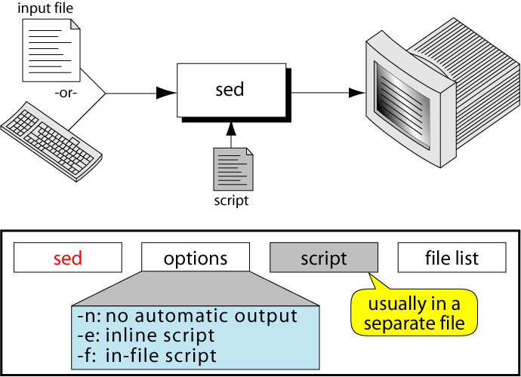
sed command syntax
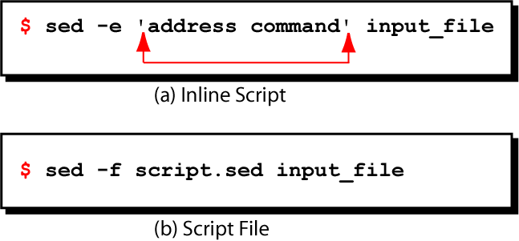
sed Operation
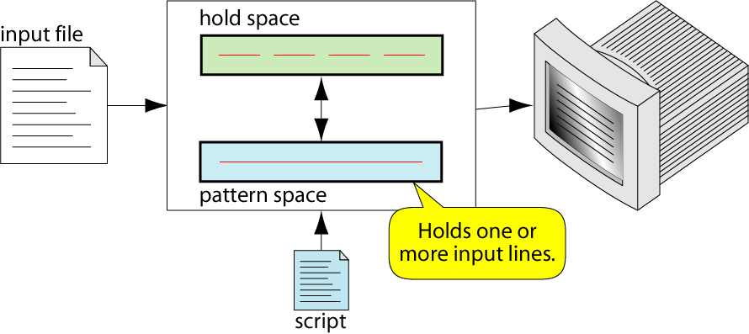
How Does sed Work?
- sed reads line of input
  - line of input is copied into a temporary buffer called pattern space
  - editing commands are applied
    - subsequent commands are applied to line in the pattern space, not the original input line
    - once finished, line is sent to output
(unless –n option was used)
  - line is removed from pattern space
- sed reads next line of input, until end of file
Note: input file is unchanged
sed instruction format
- address determines which lines in the input file are to be processed by the command(s)
  - if no address is specified, then the command is applied to each input line
- address types:
  - Single-Line address
  - Set-of-Lines address
  - Range address
  - Nested address
Single-Line Address
- Specifies only one line in the input file
  - special: dollar sign ($) denotes last line of input file
Examples:
  - show only line 3
sed -n -e '3 p' input-file
  - show only last line
sed -n -e '$ p' input-file
  - substitute “endif” with “fi” on line 10
sed -e '10 s/endif/fi/' input-file
Set-of-Lines Address
- use regular expression to match lines
  - written between two slashes
  - process only lines that match
  - may match several lines
  - lines may or may not be consecutives
Examples:
sed -e ‘/key/ s/more/other/’ input-file
sed -n -e ‘/r..t/ p’ input-file
Range Address
- Defines a set of consecutive lines
Format:
start-addr,end-addr (inclusive)
Examples:
10,50 line-number,line-number
10,/R.E/ line-number,/RegExp/
/R.E./,10 /RegExp/,line-number
/R.E./,/R.E/ /RegExp/,/RegExp/
Example: Range Address
% sed -n -e ‘/^BEGIN$/,/^END$/p’ input-file
- Print lines between BEGIN and END, inclusive
BEGIN
Line 1 of input
Line 2 of input
Line3 of input
END
Line 4 of input
Line 5 of input
Nested Address
- Nested address contained within another address

Example:
print blank lines between line 20 and 30
20,30{
/^$/ p
}
Address with !
- address with an exclamation point (!):
instruction will be applied to all lines that do not match the address
Example:
print lines that do not contain “obsolete”
sed -e ‘/obsolete/!p’ input-file
sed commands
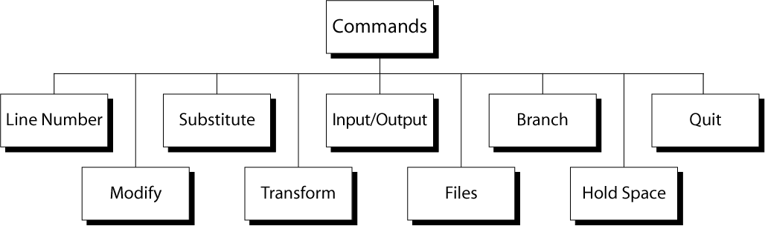
Line Number
- line number command (=) writes the current line number before each matched/output line
Examples:
sed -e '/Two-thirds-time/=' tuition.data
sed -e '/^[0-9][0-9]/=' inventory
modify commands
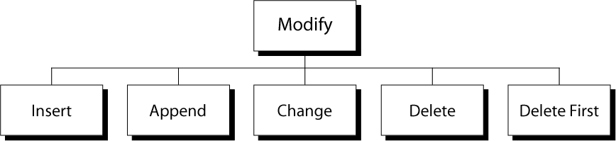
Insert Command: i
- adds one or more lines directly to the output before the address:
  - inserted “text” never appears in sed’s pattern space
  - cannot be used with a range address; can only be used with the single-line and set-of-lines address types
Syntax:
[address] i\
text
Append Command: a
- adds one or more lines directly to the output after the address:
  - Similar to the insert command (i), append cannot be used with a range address.
  - Appended “text” does not appear in sed’s pattern space.
Syntax:
[address] a\
text
Change Command: c
- replaces an entire matched line with new text
- accepts four address types:
  - single-line, set-of-line, range, and nested addresses.
Syntax:
[address1[,address2]] c\
text
Delete Command: d
- deletes the entire pattern space
  - commands following the delete command are ignored since the deleted text is no longer in the pattern space
Syntax:
[address1[,address2]] d
Substitute Command (s)
Syntax:
[addr1][,addr2] s/search/replace/[flags]
- replaces text selected by search string with replacement string
- search string can be regular expression
- flags:
  - global (g), i.e. replace all occurrences
  - specific substitution count (integer), default 1
Regular Expressions: use with sed
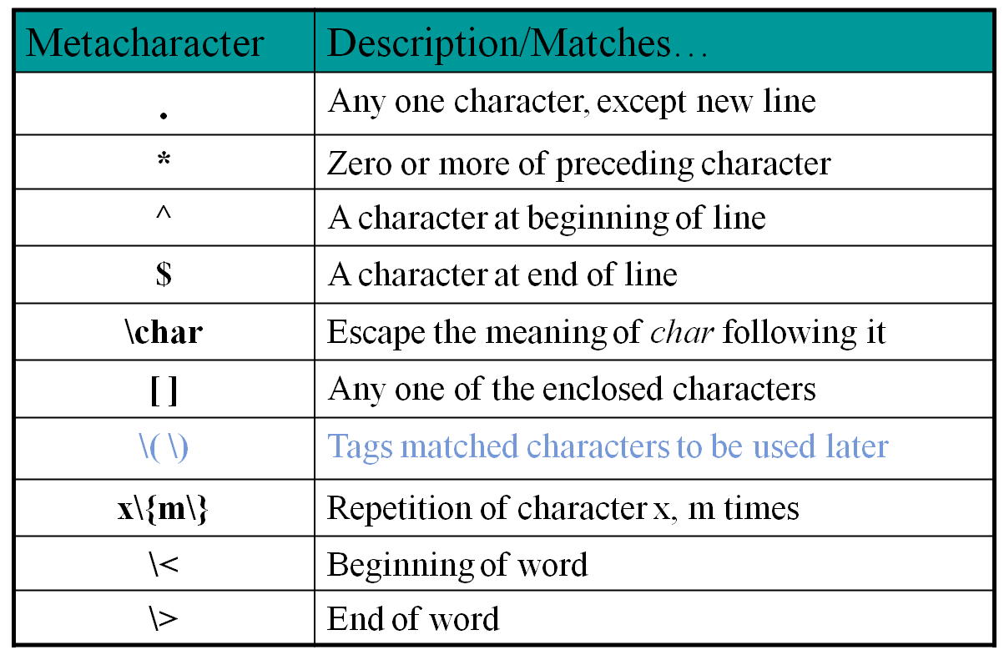
Substitution Back References
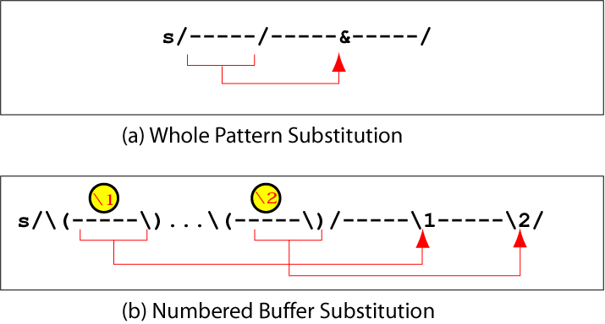
Example: Replacement String &
$ cat datafile
Charles Main 3.0 .98 3 34
Sharon Gray 5.3 .97 5 23
Patricia Hemenway 4.0 .7 4 17
TB Savage 4.4 .84 5 20
AM Main Jr. 5.1 .94 3 13
Margot Weber 4.5 .89 5 9
Ann Stephens 5.7 .94 5 13
$ sed -e ‘s/[0-9][0-9]$/&.5/’ datafile
Charles Main 3.0 .98 3 34.5
Sharon Gray 5.3 .97 5 23.5
Patricia Hemenway 4.0 .7 4 17.5
TB Savage 4.4 .84 5 20.5
AM Main Jr. 5.1 .94 3 13.5
Margot Weber 4.5 .89 5 9
Ann Stephens 5.7 .94 5 13.5
Transform Command (y)
Syntax:
[addr1][,addr2]y/a/b/
  - translates one character 'a' to another 'b'
  - cannot use regular expression metacharacters
  - cannot indicate a range of characters
  - similar to “tr” command
Example:
$ sed -e ‘1,10y/abcd/wxyz/’ datafile
sed i/o commands
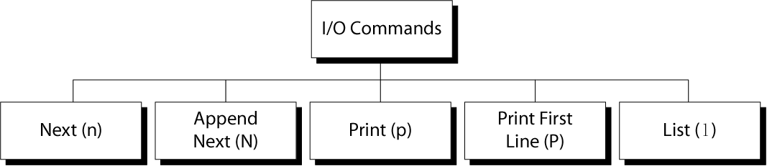
Input (next) Command: n and N
- Forces sed to read the next input line
  - Copies the contents of the pattern space to output
  - Deletes the current line in the pattern space
  - Refills it with the next input line
  - Continue processing
- N (uppercase) Command
  - adds the next input line to the current contents of the pattern space
  - useful when applying patterns to two or more lines at the same time
Output Command: p and P
- Print Command (p)
  - copies the entire contents of the pattern space to output
  - will print same line twice unless the option “–n” is used
- Print command: P
  - prints only the first line of the pattern space
  - prints the contents of the pattern space up to and including a new line character
  - any text following the first new line is not printed
List Command (l)
- The list command: l
  - shows special characters (e.g. tab, etc)
- The octal dump command (od -c) can be used to produce similar result
Hold Space
- temporary storage area
used to save the contents of the pattern space
- 4 commands that can be used to move text back and forth between the pattern space and the hold space:
h, H
g, G
File commands
- allows to read and write from/to file while processing standard input
- read: r command
- write: w command
Read File command
Syntax: r filename
  - queue the contents of filename to be read and inserted into the output stream at the end of the current cycle, or when the next input line is read
    - if filename cannot be read, it is treated as if it were an empty file, without any error indication
  - single address only
Write File command
Syntax: w filename
  - Write the pattern space to filename
  - The filename will be created (or truncated) before the first input line is read
  - all w commands which refer to the same filename are output through the same FILE stream
Branch Command (b)
- Change the regular flow of the commands in the script file
Syntax: [addr1][,addr2]b[label]
  - Branch (unconditionally) to ‘label’ or end of script
  - If “label” is supplied, execution resumes at the line following :label; otherwise, control passes to the end of the script
- Branch label
:mylabel
Example: The quit (q) Command
Syntax: [addr]q
  - Quit (exit sed) when addr is encountered.
Example: Display the first 50 lines and quit
% sed -e ’50q’ datafile

Same as:
% sed -n -e ‘1,50p’ datafile
% head -50 datafile
AWK
What is awk?
- created by: Aho, Weinberger, and Kernighan
- scripting language used for manipulating data and generating reports
- versions of awk
  - awk, nawk, mawk, pgawk, …
  - GNU awk: gawk
What can you do with awk?
- awk operation:
  - scans a file line by line
  - splits each input line into fields
  - compares input line/fields to pattern
  - performs action(s) on matched lines
- Useful for:
  - transform data files
  - produce formatted reports
- Programming constructs:
  - format output lines
  - arithmetic and string operations
  - conditionals and loops

The Command: awk
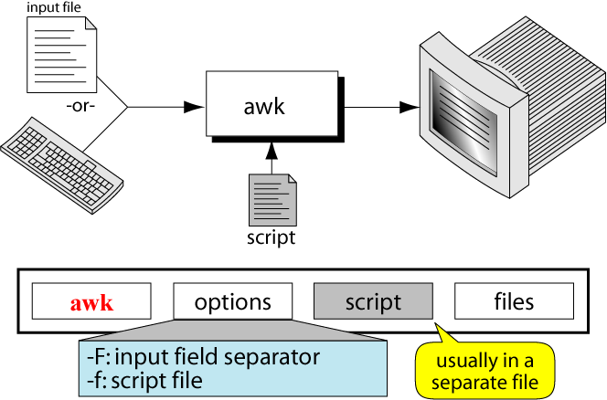
Basic awk Syntax
- awk [options] ‘script’ file(s)
- awk [options] –f scriptfile file(s)
Options:
-F to change input field separator
-f to name script file
Basic awk Program
- consists of patterns & actions:
pattern {action}
  - if pattern is missing, action is applied to all lines
  - if action is missing, the matched line is printed
  - must have either pattern or action
Example:
awk '/for/' testfile
  - prints all lines containing string “for” in testfile
Basic Terminology: input file
- A field is a unit of data in a line
- Each field is separated from the other fields by the field separator
  - default field separator is whitespace
- A record is the collection of fields in a line
- A data file is made up of records
Example Input File
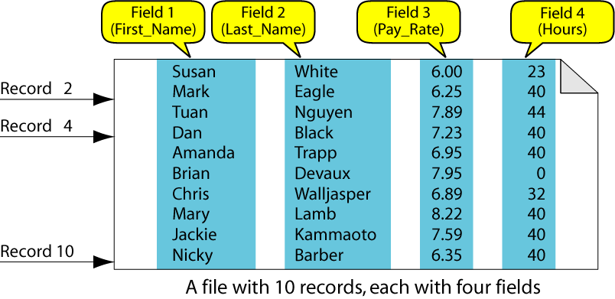
Buffers
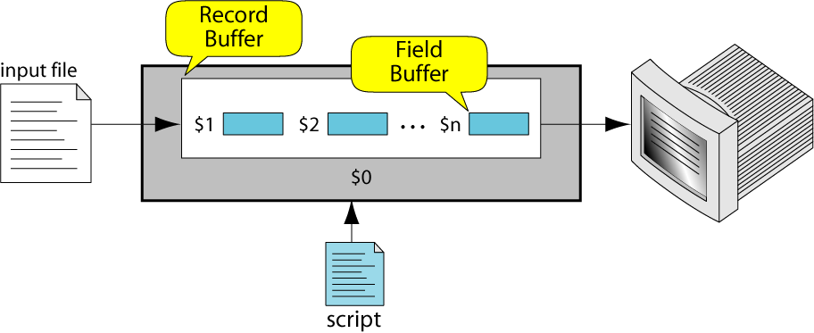
- awk supports two types of buffers:
record and field
- field buffer:
  - one for each fields in the current record.
  - names: $1, $2, …
- record buffer :
  - $0 holds the entire record
Some System Variables
FS Field separator (default=whitespace)
RS Record separator (default=\n)
NF Number of fields in current record
NR Number of the current record
OFS Output field separator (default=space)
ORS Output record separator (default=\n)
FILENAME Current filename
Example: Records and Fields
% cat emps
Tom Jones 4424 5/12/66 543354
Mary Adams 5346 11/4/63 28765
Sally Chang 1654 7/22/54 650000
Billy Black 1683 9/23/44 336500
% awk '{print NR, $0}' emps
1 Tom Jones 4424 5/12/66 543354
2 Mary Adams 5346 11/4/63 28765
3 Sally Chang 1654 7/22/54 650000
4 Billy Black 1683 9/23/44 336500
Example: Space as Field Separator
% cat emps
Tom Jones 4424 5/12/66 543354
Mary Adams 5346 11/4/63 28765
Sally Chang 1654 7/22/54 650000
Billy Black 1683 9/23/44 336500
% awk '{print NR, $1, $2, $5}' emps
1 Tom Jones 543354
2 Mary Adams 28765
3 Sally Chang 650000
4 Billy Black 336500
Example: Colon as Field Separator
% cat em2
Tom Jones:4424:5/12/66:543354
Mary Adams:5346:11/4/63:28765
Sally Chang:1654:7/22/54:650000
Billy Black:1683:9/23/44:336500
% awk -F: '/Jones/{print $1, $2}' em2
Tom Jones 4424
awk Scripts
- awk scripts are divided into three major parts:
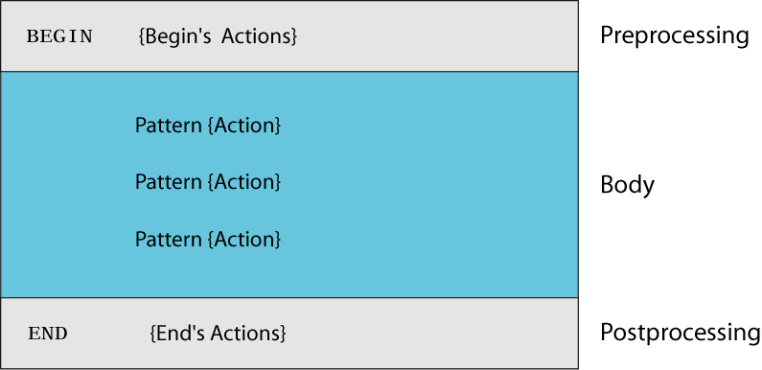
- comment lines start with #
awk Scripts
- BEGIN: pre-processing
  - performs processing that must be completed before the file processing starts (i.e., before awk starts reading records from the input file)
  - useful for initialization tasks such as to initialize variables and to create report headings
- BODY: Processing
  - contains main processing logic to be applied to input records
  - like a loop that processes input data one record at a time:
    - if a file contains 100 records, the body will be executed 100 times, one for each record
- END: post-processing
  - contains logic to be executed after all input data have been processed
  - logic such as printing report grand total should be performed in this part of the script
Pattern / Action Syntax
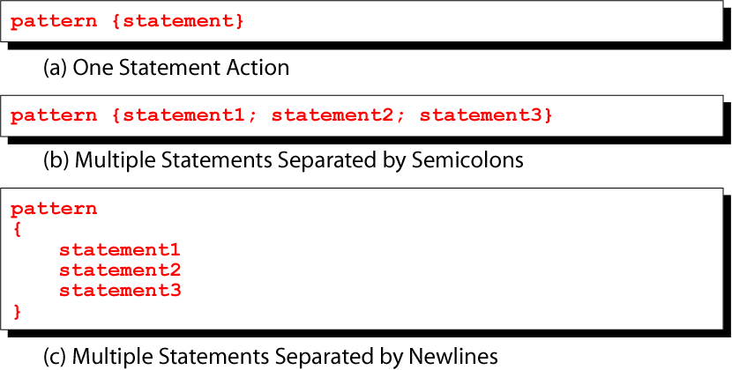

Categories of Patterns
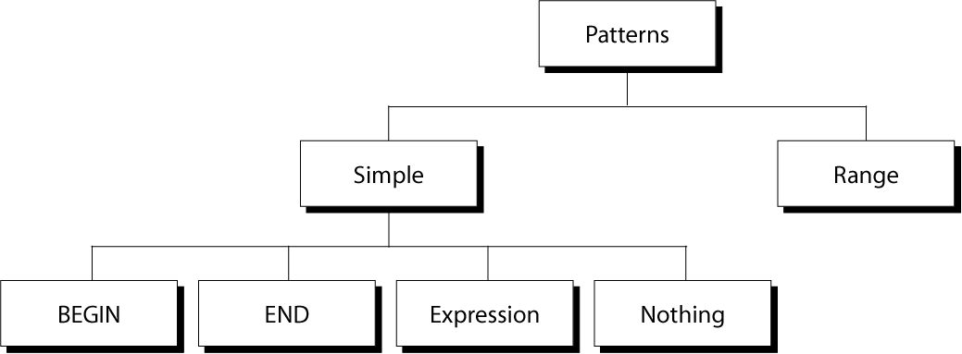
Expression Pattern types
- match
  - entire input record
regular expression enclosed by ‘/’s
  - explicit pattern-matching expressions
~ (match), !~ (not match)
- expression operators
  - arithmetic
  - relational
  - logical
Example: match input record
% cat employees2
Tom Jones:4424:5/12/66:543354
Mary Adams:5346:11/4/63:28765
Sally Chang:1654:7/22/54:650000
Billy Black:1683:9/23/44:336500
% awk –F: '/00$/' employees2
Sally Chang:1654:7/22/54:650000
Billy Black:1683:9/23/44:336500
Example: explicit match
% cat datafile
northwest NW Charles Main 3.0 .98 3 34
western WE Sharon Gray 5.3 .97 5 23
southwest SW Lewis Dalsass 2.7 .8 2 18
southern SO Suan Chin 5.1 .95 4 15
southeast SE Patricia Hemenway 4.0 .7 4 17
eastern EA TB Savage 4.4 .84 5 20
northeast NE AM Main 5.1 .94 3 13
north NO Margot Weber 4.5 .89 5 9
central CT Ann Stephens 5.7 .94 5 13
% awk '$5 ~ /\.[7-9]+/' datafile
southwest SW Lewis Dalsass 2.7 .8 2 18
central CT Ann Stephens 5.7 .94 5 13
Examples: matching with REs
% awk '$2 !~ /E/{print $1, $2}' datafile
northwest NW
southwest SW
southern SO
north NO
central CT
% awk '/^[ns]/{print $1}' datafile
northwest
southwest
southern
southeast
northeast
north
Arithmetic Operators
Operator Meaning Example
+ Add x + y
- Subtract x – y
* Multiply x * y
/ Divide x / y
% Modulus x % y
^ Exponential x ^ y
Example:
% awk '$3 * $4 > 500 {print $0}' file
Relational Operators
Operator Meaning Example
< Less than x < y
< = Less than or equal x < = y
== Equal to x == y
!= Not equal to x != y
> Greater than x > y
> = Greater than or equal to x > = y
~ Matched by reg exp x ~ /y/
!~ Not matched by req exp x !~ /y/
Logical Operators
Operator Meaning Example
&& Logical AND a && b
|| Logical OR a || b
! NOT ! a
Examples:
% awk '($2 > 5) && ($2 <= 15) {print $0}' file
% awk '$3 == 100 || $4 > 50' file
Range Patterns
- Matches ranges of consecutive input lines
Syntax:
pattern1 , pattern2 {action}
- pattern can be any simple pattern
- pattern1 turns action on
- pattern2 turns action off
Range Pattern Example
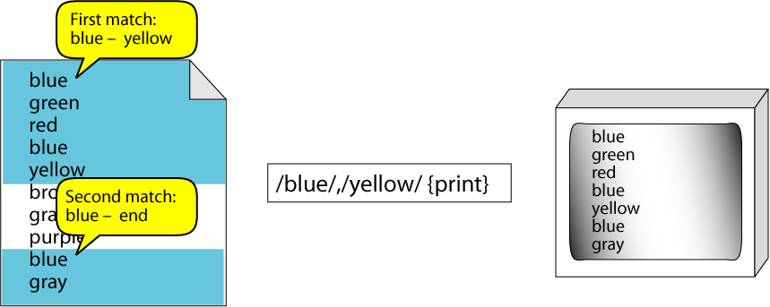
awk Actions
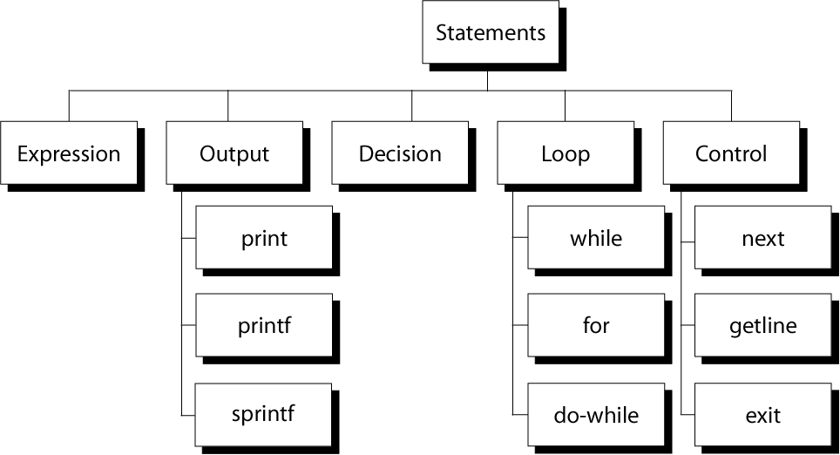
awk expressions
- Expression is evaluated and returns value
  - consists of any combination of numeric and string constants, variables, operators, functions, and regular expressions
- Can involve variables
  - As part of expression evaluation
  - As target of assignment
awk variables
- A user can define any number of variables within an awk script
- The variables can be numbers, strings, or arrays
- Variable names start with a letter, followed by letters, digits, and underscore
- Variables come into existence the first time they are referenced; therefore, they do not need to be declared before use
- All variables are initially created as strings and initialized to a null string “”
awk Variables
Format:
variable = expression
Examples:

% awk '$1 ~ /Tom/
{wage = $3 * $4; print wage}' filename
% awk '$4 == "CA" {$4 = "California"; print $0}' filename
awk assignment operators
= assign result of right-hand-side expression to
left-hand-side variable
++ Add 1 to variable
-- Subtract 1 from variable
+= Assign result of addition
-= Assign result of subtraction
*= Assign result of multiplication
/= Assign result of division
%= Assign result of modulo
^= Assign result of exponentiation
Awk example
- File: grades
john 85 92 78 94 88
andrea 89 90 75 90 86
jasper 84 88 80 92 84
- awk script: average
# average five grades
{ total = $2 + $3 + $4 + $5 + $6
avg = total / 5
print $1, avg }
- Run as:
awk –f average grades
Output Statements
print
print easy and simple output
printf
print formatted (similar to C printf)
sprintf
format string (similar to C sprintf)
Function: print
- Writes to standard output
- Output is terminated by ORS
  - default ORS is newline
- If called with no parameter, it will print $0
- Printed parameters are separated by OFS,
  - default OFS is blank
- Print control characters are allowed:
  - \n \f \a \t \\ …
print example
% awk '{print}' grades
john 85 92 78 94 88
andrea 89 90 75 90 86
% awk '{print $0}' grades
john 85 92 78 94 88
andrea 89 90 75 90 86
% awk '{print($0)}' grades
john 85 92 78 94 88
andrea 89 90 75 90 86
Redirecting print output
- Print output goes to standard output
unless redirected via:
> “file”
>> “file”
| “command”
- will open file or command only once
- subsequent redirections append to already open stream
print Example
% awk '{print $1 , $2 > "file"}' grades
% cat file
john 85
andrea 89
jasper 84
% awk '{print $1,$2 | "sort"}' grades
andrea 89
jasper 84
john 85
% awk '{print $1,$2 | "sort –k 2"}' grades
jasper 84
john 85
andrea 89
% date
Wed Nov 19 14:40:07 CST 2008
% date |
awk '{print "Month: " $2 "\nYear: ", $6}'
Month: Nov
Year: 2008
printf: Formatting output
Syntax:
printf(format-string, var1, var2, …)
  - works like C printf
  - each format specifier in “format-string” requires argument of matching type
Format specifiers
%d, %i decimal integer
%c single character
%s string of characters
%f floating point number
%o octal number
%x hexadecimal number
%e scientific floating point notation
%% the letter “%”
Format specifier examples
Given: x = ‘A’, y = 15, z = 2.3, and $1 = Bob Smith
Printf Format Specifier | What it Does
%c | printf("The character is %c \n", x)  output: The character is A
%d | printf("The boy is %d years old \n", y)  output: The boy is 15 years old
%s | printf("My name is %s \n", $1)  output: My name is Bob Smith
%f | printf("z is %5.3f \n", z)  output: z is 2.300
Format specifier modifiers
- between “%” and letter
%10s
%7d
%10.4f
%-20s
- meaning:
  - width of field, field is printed right justified
  - precision: number of digits after decimal point
  - “-” will left justify
sprintf: Formatting text
Syntax:
sprintf(format-string, var1, var2, …)
  - Works like printf, but does not produce output
  - Instead it returns formatted string
Example:
{
text = sprintf("1: %d – 2: %d", $1, $2)
print text
}
awk builtin functions
tolower(string)
- returns a copy of string, with each upper-case character converted to lower-case. Nonalphabetic characters are left unchanged.
Example: tolower("MiXeD cAsE 123")
returns "mixed case 123"
toupper(string)
- returns a copy of string, with each lower-case character converted to upper-case.
awk Example: list of products
103:sway bar:49.99
101:propeller:104.99
104:fishing line:0.99
113:premium fish bait:1.00
106:cup holder:2.49
107:cooler:14.89
112:boat cover:120.00
109:transom:199.00
110:pulley:9.88
105:mirror:4.99
108:wheel:49.99
111:lock:31.00
102:trailer hitch:97.95
awk Example: output
Marine Parts R Us
Main catalog
Part-id name price
======================================
101 propeller 104.99
102 trailer hitch 97.95
103 sway bar 49.99
104 fishing line 0.99
105 mirror 4.99
106 cup holder 2.49
107 cooler 14.89
108 wheel 49.99
109 transom 199.00
110 pulley 9.88
111 lock 31.00
112 boat cover 120.00
113 premium fish bait 1.00
======================================
Catalog has 13 parts
awk Example: complete
BEGIN {
FS= ":"
print "Marine Parts R Us"
print "Main catalog"
print "Part-id\tname\t\t\t price"
print "======================================"
}
{
printf("%3d\t%-20s\t%6.2f\n", $1, $2, $3)
count++
}
END {
print "======================================"
print "Catalog has " count " parts"
}
awk Array
- awk allows one-dimensional arrays
to store strings or numbers
- index can be number or string
- array need not be declared
  - its size
  - its elements
- array elements are created when first used
  - initialized to 0 or “”
Arrays in awk
Syntax:
arrayName[index] = value
Examples:
list[1] = "one"
list[2] = "three"
list["other"] = "oh my !"
Illustration: Associative Arrays
- awk arrays can use string as index
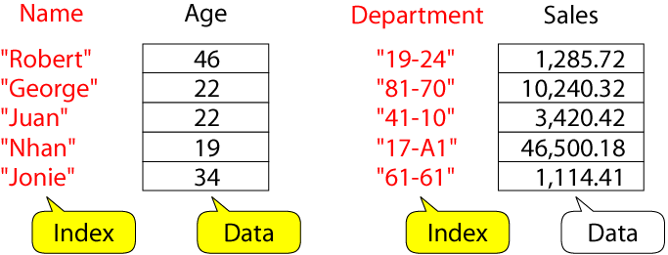
Awk builtin split function
split(string, array, fieldsep)
  - divides string into pieces separated by fieldsep, and stores the pieces in array
  - if the fieldsep is omitted, the value of FS is used.
Example:
split("auto-da-fe", a, "-")
- sets the contents of the array a as follows:
a[1] = "auto"
a[2] = "da"
a[3] = "fe"
Example: process sales data
- input file:
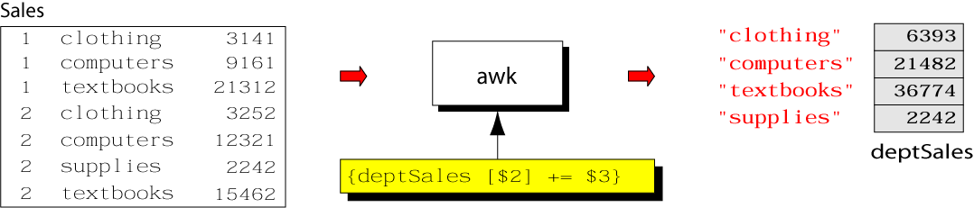
- output:
  - summary of category sales
Illustration: process each input line
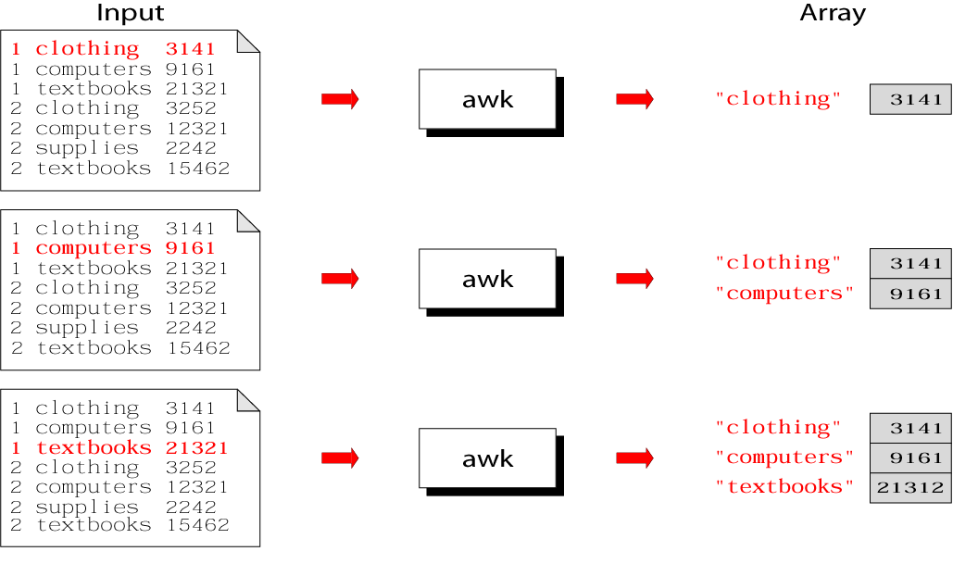
Illustration: process each input line
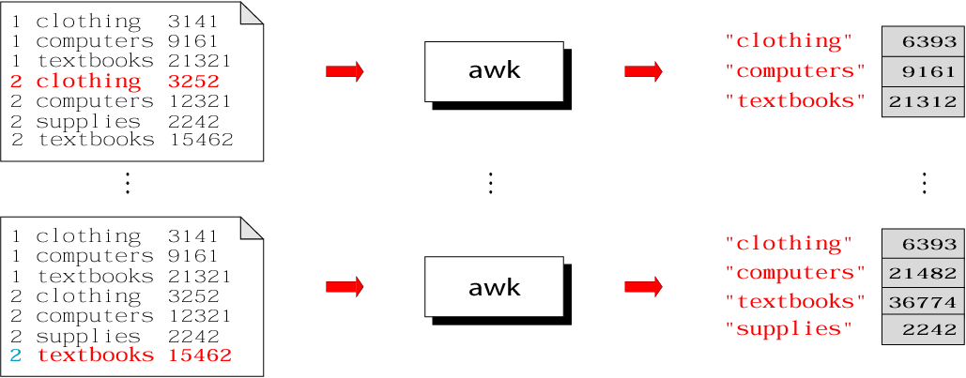
Summary: awk program
Example: complete program
% cat sales.awk
{
deptSales[$2] += $3
}
END {
for (x in deptSales)
print x, deptSales[x]
}
% awk –f sales.awk sales
Awk control structures
- Conditional
  - if-else
- Repetition
  - for
    - with counter
    - with array index
  - while
  - do-while
  - also: break, continue
if Statement
Syntax:
if (conditional expression)
statement-1
else
statement-2
Example:
if ( NR < 3 )
print $2
else
print $3
for Loop
Syntax:
for (initialization; limit-test; update)
statement
Example:
for (i = 1; i <= NR; i++)
{
total += $i
count++
}
for Loop for arrays
Syntax:
for (var in array)
statement
Example:
for (x in deptSales)
{
print x, deptSales[x]
}
while Loop
Syntax:
while (logical expression)
statement
Example:
i = 1
while (i <= NF)
{
print i, $i
i++
}
do-while Loop
Syntax:
do
statement
while (condition)
- statement is executed at least once, even if condition is false at the beginning
Example:
i = 1
do {
print $0
i++
} while (i <= 10)
loop control statements
- break

